DROM NewS
Jam-Packed January!

Congratulations Chloe
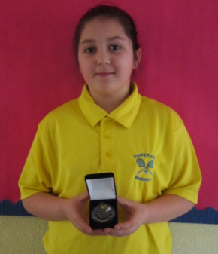


On Sunday 24th January Chloe took part in the Munster Badminton Championship. She represented Tipperary on the under 11 Badminton team. Her team were the Munster Final runners up.
Well done Chloe.

ENROLMENT: 2016 / 2017
Enrolment applications for 2016 / 2017 are now being accepted. Please call the school for an enrolment pack or to arrange a visit. We would be delighted to meet with you and your child. We would also appreciate if you could spread the word amongst your family and friends. For more information or to receive an enrolment application form, please call the school on (0504) 51688. We look forward to hearing from you.

January
SCHOOL LEAGUE
The school hurling league started on Wednesday, 27th January. Ambrose Purcell has again this year kindly agreed to run the league. There are four teams in the league. The team captains are: Daithí Lawlor, Gavin Shanahan, Caitlin Black and Kate Lawlor.
The first match saw Daithí Lawlor’s team play Caitlin Black’s team. Both teams fought hard to be the first to score, it was TJ Kinnane from Daithí’s team who scored the first of a few goals putting his team in the lead. In the second half Corbin O’Toole scored a goal for Caitlin's team. Daithí's team emerged the victors in what was a very good performance from both teams.
The second match, which takes place next Wednesday, will be played between Gavin Shanahan’s team and Kate Lawlor’s team.
Best of Luck to all involved.

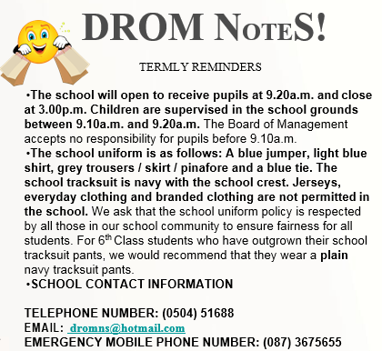
Credit Union Quiz
Since we have returned to school we have been busy preparing for the Credit Union Quiz. This year we will enter two teams.

Team 1:
Maeve Healion
April Glasheen
Jane Brereton
Olivia Delargy

Team 2:
Rachel Ryan Jonah Ryan Emma Cody
Daithí Lawlor

We wish them the very best of luck!

IRISH DANCING

Irish dancing with Sinéad Cahill started on Monday, 11th January and will progress until Monday, 14th March. We are busy learning the basic steps and traditional Irish dances, as well as some more modern versions too.

Tracksuit days for this term will be Mondays and Fridays.

NEWS



